Q. WAP by using buttons to establish connection to SQL Server, and also show the instance name, server database name, and current state of the connection.
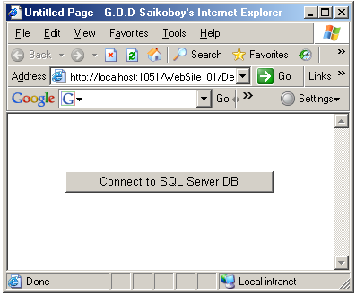

using System;
using System.Data;
using System.Configuration;
using System.Web;
using System.Web.Security;
using System.Web.UI;
using System.Web.UI.WebControls;
using System.Web.UI.WebControls.WebParts;
using System.Web.UI.HtmlControls;
using System.Data.SqlClient;
using System.Windows.Forms;

public partial class _Default : System.Web.UI.Page
{
SqlConnection con;
protected void Button1_Click(object sender, EventArgs e)
{
con = new SqlConnection("Integrated Security=SSPI;Persist Security Info=False;Initial Catalog=C#Prac;Data Source=.");
con.Open();
MessageBox .Show ("Connection established to SQL Server", "Connection");
MessageBox.Show("SQL Server Instance Name=" + con.DataSource, "Connection");
MessageBox.Show("SQL Server Database Name=" + con.Database, "Connection");
MessageBox.Show("Current state of the connection with SQL Server database=" + con.State, "Connection");
con.Close();
MessageBox.Show("Current state of the connection with SQL Server database=" + con.State, "Connection");
}
}

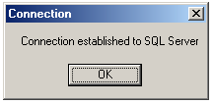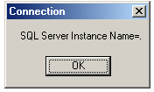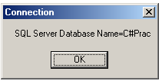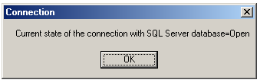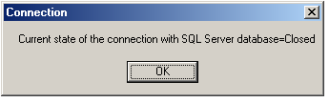
Q. WAP to connect to a website next page after login (filling valid user id and password.)
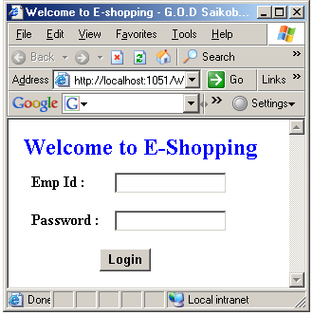

using System;
using System.Data;
using System.Configuration;
using System.Collections;
using System.Web;
using System.Web.Security;
using System.Web.UI;
using System.Web.UI.WebControls;
using System.Web.UI.WebControls.WebParts;
using System.Web.UI.HtmlControls;
using System.Data.SqlClient;

public partial class Default2 : System.Web.UI.Page
{
SqlConnection con;
SqlCommand cmd;
SqlDataReader dr;
string sqlstmt;

protected void Button1_Click(object sender, EventArgs e)
{
con = new SqlConnection("Integrated Security=SSPI;Persist Security Info=False;Initial Catalog=C#Prac;Data Source=.");
sqlstmt = "SELECT * FROM Emp WHERE Emp_Id='" + TextBox1.Text.ToString() + "' AND Pwd='" + TextBox2.Text.ToString() + "'";
cmd = new SqlCommand(sqlstmt, con);
con.Open();
dr = cmd.ExecuteReader();
if (dr.Read())
{
Response.Redirect("ValidEmp.aspx");
}
else
{
Response.Redirect("InValidEmp.aspx");
}

}

}
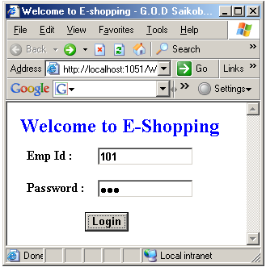
If Emp Id and Password are valid.


If Emp Id or Password is invalid or any field is blank.
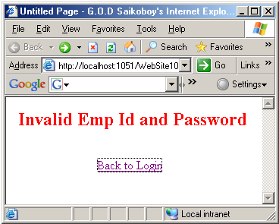

Q. WAP to save (i.e. INSERT) the student details into the student table.

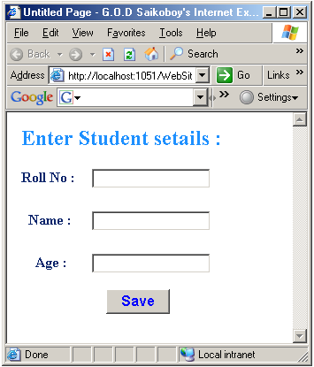
using System;
using System.Data;
using System.Configuration;
using System.Collections;
using System.Web;
using System.Web.Security;
using System.Web.UI;
using System.Web.UI.WebControls;
using System.Web.UI.WebControls.WebParts;
using System.Web.UI.HtmlControls;
using System.Data.SqlClient;

public partial class Save : System.Web.UI.Page
{
SqlConnection con;
SqlCommand cmd;
string sqlstmt;

protected void Button1_Click(object sender, EventArgs e)
{
con = new SqlConnection("Integrated Security=SSPI;Persist Security Info=False;Initial Catalog=C#Prac;Data Source=.");
sqlstmt = "INSERT INTO Stud VALUES(" + TextBox1.Text + ",'" + TextBox2.Text + "'," + TextBox3.Text + ")";
cmd = new SqlCommand(sqlstmt, con);
con.Open();
cmd.ExecuteNonQuery();
Response.Redirect("Saved.aspx");
TextBox1.Text = "";
TextBox2.Text = "";
TextBox3.Text = "";
}
}

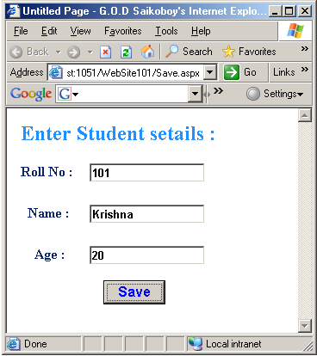

Q. WAP to display data from the SQL Server from the Dept table for Search button.
User will enter Dept no then click on Search button, it will display all details related to dept.
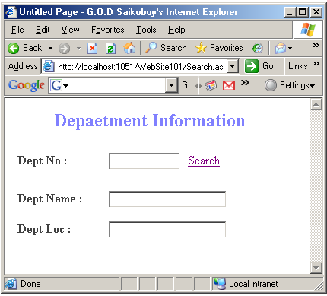

Create a table dept by using following SQL statement:
CREATE TABLE Dept
(DeptNo int Primary Key,
Dname Varchar(20) Not Null,
Loc Varchar(20) Not Null)

Code:

using System;
using System.Data;
using System.Configuration;
using System.Collections;
using System.Web;
using System.Web.Security;
using System.Web.UI;
using System.Web.UI.WebControls;
using System.Web.UI.WebControls.WebParts;
using System.Web.UI.HtmlControls;
using System.Data.SqlClient;

public partial class Search : System.Web.UI.Page
{
SqlConnection con;
SqlCommand cmd;
SqlDataReader dr;
string sqlstmt;
protected void LinkButton1_Click(object sender, EventArgs e)
{
con = new SqlConnection("Integrated Security=SSPI;Persist Security Info=False;Initial Catalog=C#Prac;Data Source=.");
sqlstmt = "SELECT dname, loc FROM Dept WHERE DeptNo=" + TextBox1.Text.ToString();
cmd = new SqlCommand(sqlstmt, con);
con.Open();
dr = cmd.ExecuteReader();
if (dr.Read())
{
TextBox2.Text = dr[0].ToString();
TextBox3.Text = dr[1].ToString();
}
else
{
Response.Redirect("InValidDept.aspx");
}
}
}
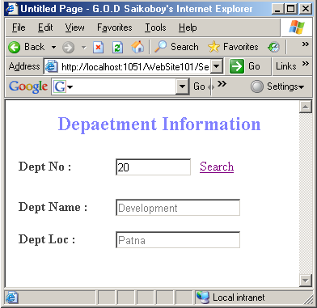
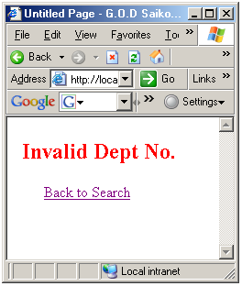

Q. WAP to save / insert data into database using Store Procedure.
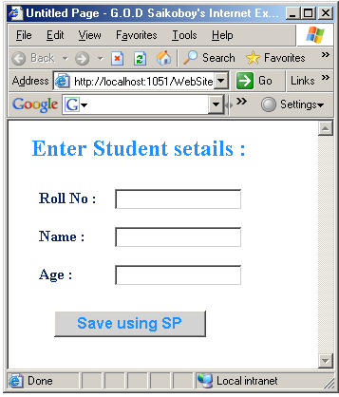
Create a table by using following SQL Statement:
CREATE TABLE Stud
(RollNo int Primary Key,
Sname Varchar(20) Not Null,
Age numeric(2,0))

Create one SP by using following SQL Statement:
CREATE PROC InsData
(@RollNo int,@Sname Varchar(20),@Age Numeric(2,0))
AS
INSERT INTO Stud
VALUES(@RollNo, @Sname, @Age)

Code:
using System;
using System.Data;
using System.Configuration;
using System.Collections;
using System.Web;
using System.Web.Security;
using System.Web.UI;
using System.Web.UI.WebControls;
using System.Web.UI.WebControls.WebParts;
using System.Web.UI.HtmlControls;
using System.Data.SqlClient;

public partial class SaveUsingSP : System.Web.UI.Page
{
SqlConnection con;
SqlCommand cmd;
SqlParameter p1, p2, p3;

protected void Button1_Click(object sender, EventArgs e)
{
con = new SqlConnection("Integrated Security=SSPI;Persist Security Info=False;Initial Catalog=C#Prac;Data Source=.");
cmd = new SqlCommand("InsData", con);
cmd.CommandType = CommandType.StoredProcedure;
p1 = new SqlParameter("@RollNo", SqlDbType.Int);
p2 = new SqlParameter("@Sname", SqlDbType.VarChar);
p3 = new SqlParameter("@Age", SqlDbType.Int);
p1.Value = int.Parse(TextBox1.Text);
p2.Value = TextBox2.Text;
p3.Value = int.Parse(TextBox3.Text);
cmd.Parameters.Add(p1);
cmd.Parameters.Add(p2);
cmd.Parameters.Add(p3);
con.Open();
cmd.ExecuteNonQuery();
con.Close();
Response.Redirect("SavedUsingSP.aspx");
}
}

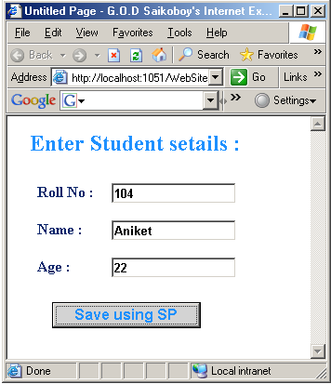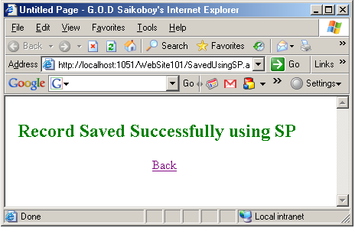

Q. WAP by using GridView control. If user clicks on “Get Data “ button, data will be fetched from the dept table and show in grid view control.
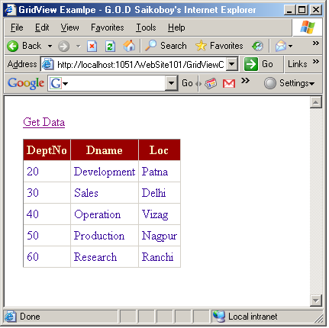

Code:
using System;
using System.Data;
using System.Configuration;
using System.Collections;
using System.Web;
using System.Web.Security;
using System.Web.UI;
using System.Web.UI.WebControls;
using System.Web.UI.WebControls.WebParts;
using System.Web.UI.HtmlControls;
using System.Data.SqlClient;

public partial class GridViewControl1 : System.Web.UI.Page
{
SqlConnection con;
SqlDataAdapter da;
DataSet ds;

protected void LinkButton1_Click(object sender, EventArgs e)
{
con = new SqlConnection("Integrated Security=SSPI;Persist Security Info=False;Initial Catalog=C#Prac;Data Source=.");
ds = new DataSet();
da = new SqlDataAdapter("SELECT * FROM Dept", con);
da.Fill(ds, "Stud");
GridView1.DataSource = ds.Tables[0];
GridView1.DataBind();
}
}

Q. WAP to display related employee details after selecting dept no. from combo box.
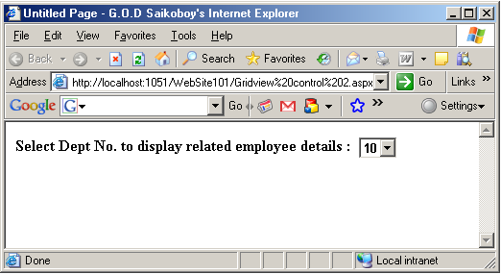
using System;
using System.Data;
using System.Configuration;
using System.Collections;
using System.Web;
using System.Web.Security;
using System.Web.UI;
using System.Web.UI.WebControls;
using System.Web.UI.WebControls.WebParts;
using System.Web.UI.HtmlControls;
using System.Data.SqlClient;

public partial class Gridview_control_2 : System.Web.UI.Page
{
SqlConnection con;
SqlCommand cmd;
SqlDataAdapter da;
SqlDataReader dr;
DataSet ds;
string sqlstmt;

protected void Page_Load(object sender, EventArgs e)
{
con = new SqlConnection("Integrated Security=SSPI;Persist Security Info=False;Initial Catalog=C#Prac;Data Source=.");
sqlstmt = "Select distinct DeptNo From Emp";
cmd = new SqlCommand(sqlstmt, con);
con.Open();
dr = cmd.ExecuteReader();
while (dr .Read ())
DropDownList1 .Items .Add (dr [0] .ToString ());
dr.Close();
con.Close();
}
protected void DropDownList1_SelectedIndexChanged(object sender, EventArgs e)
{
ds = new DataSet();
da = new SqlDataAdapter("SELECT * FROM Emp Where DeptNo="+int.Parse(DropDownList1 .SelectedItem .ToString ()), con);
da.Fill(ds, "Emp");
GridView1.DataSource = ds.Tables[0];
GridView1.DataBind();
}
}

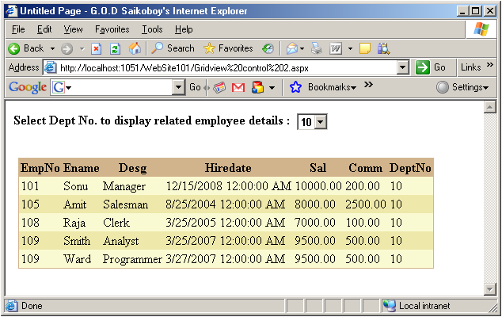

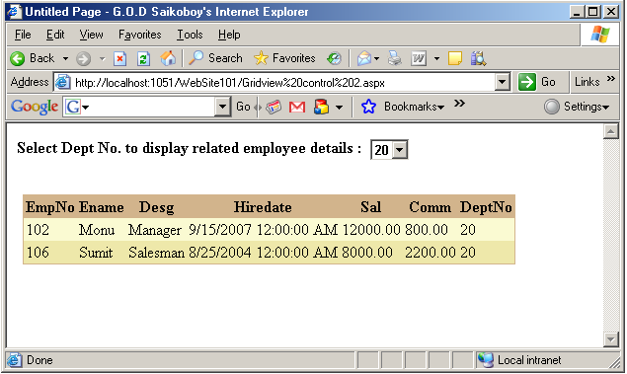

Q. WAP to take input from users like Name, Age, Marital Status, Qualification and gender and store it into database.
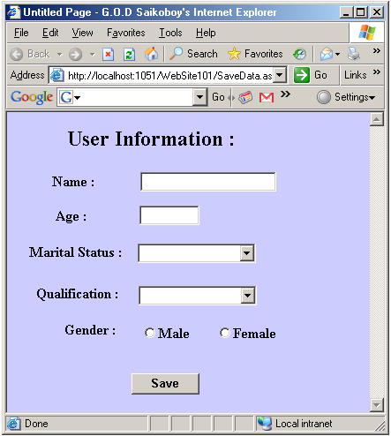

using System;
using System.Data;
using System.Configuration;
using System.Collections;
using System.Web;
using System.Web.Security;
using System.Web.UI;
using System.Web.UI.WebControls;
using System.Web.UI.WebControls.WebParts;
using System.Web.UI.HtmlControls;
using System.Data.SqlClient;

public partial class SaveData : System.Web.UI.Page
{
SqlConnection con;
SqlCommand cmd;
string sqlstmt;

protected void Button1_Click(object sender, EventArgs e)
{
string gen;
if (RadioButton1.Checked)
gen = "Male";
else
gen = "Female";

con = new SqlConnection("Integrated Security=SSPI;Persist Security Info=False;Initial Catalog=C#Prac;Data Source=.");
sqlstmt = "INSERT INTO User_tab VALUES('" + TextBox1.Text + "'," + int.Parse(TextBox2.Text) + ",'" + DropDownList1.SelectedItem + "','" + DropDownList2.SelectedItem + "','" + gen.ToString() + "')";
cmd = new SqlCommand(sqlstmt, con);
con.Open();
cmd.ExecuteNonQuery();
con.Close();
Response.Write("Content Stored in the Database");
}
protected void Page_Load(object sender, EventArgs e)
{
string[] qln ={ "MCA", "MBA", "BCA", "BBA" };
string[] ms ={"Single","Married","Divorced","Widowed"};
foreach (string s in qln)
DropDownList1 .Items .Add (s);
foreach (string s in ms )
DropDownList2 .Items .Add (s );

}
}

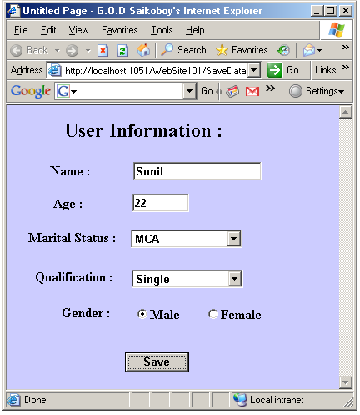



Q. WAP for traversing likes first, next, previous and last record.
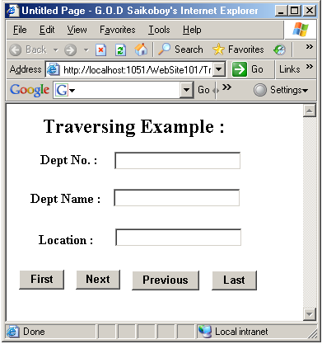

Code:
using System;
using System.Data;
using System.Configuration;
using System.Collections;
using System.Web;
using System.Web.Security;
using System.Web.UI;
using System.Web.UI.WebControls;
using System.Web.UI.WebControls.WebParts;
using System.Web.UI.HtmlControls;
using System.Data.SqlClient;
using System.Windows.Forms;

public partial class Traversing : System.Web.UI.Page
{
SqlConnection con;
SqlDataAdapter da;
DataSet ds;
DataTable dt;
DataRow dr;
int recno;

void disdata()
{
dr = dt.Rows[recno];
TextBox1.Text = dr[0].ToString();
TextBox2.Text = dr[1].ToString();
TextBox3.Text = dr[2].ToString();
}

protected void Page_Load(object sender, EventArgs e)
{
con = new SqlConnection("Integrated Security=SSPI;Persist Security Info=False;Initial Catalog=C#Prac;Data Source=.");
ds = new DataSet();
da = new SqlDataAdapter("SELECT * FROM Dept", con);
da.Fill(ds, "Dept");
dt = ds.Tables[0];
disdata();
}
protected void Button1_Click(object sender, EventArgs e)//First
{
recno = 0;
disdata();
}
protected void Button2_Click(object sender, EventArgs e)//Next
{
recno++;
if (recno > ds.Tables[0].Rows.Count - 1)
MessageBox.Show("No record exists after this record as it is the last record");
else
disdata();
}
protected void Button3_Click(object sender, EventArgs e)//Previous
{
recno--;
if (recno <0)
MessageBox.Show("This is the first record, no record before this exists");
else
disdata();
}

protected void Button4_Click(object sender, EventArgs e)//Last
{
recno = ds.Tables[0].Rows.Count - 1;
disdata();
}
}

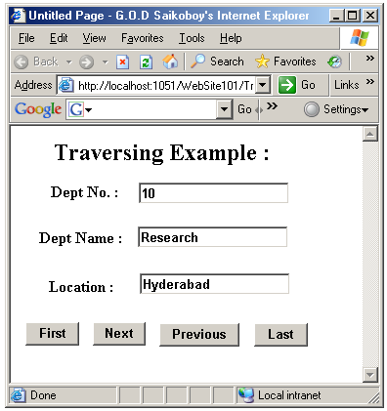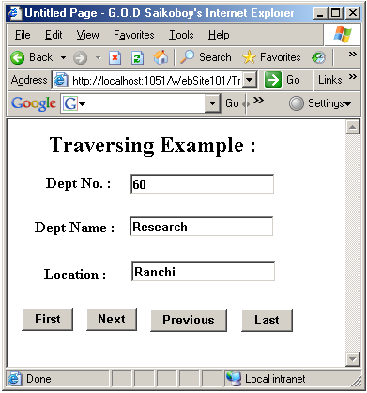

Q. WAP using Gridview control and display custom table heading and data from emp table.

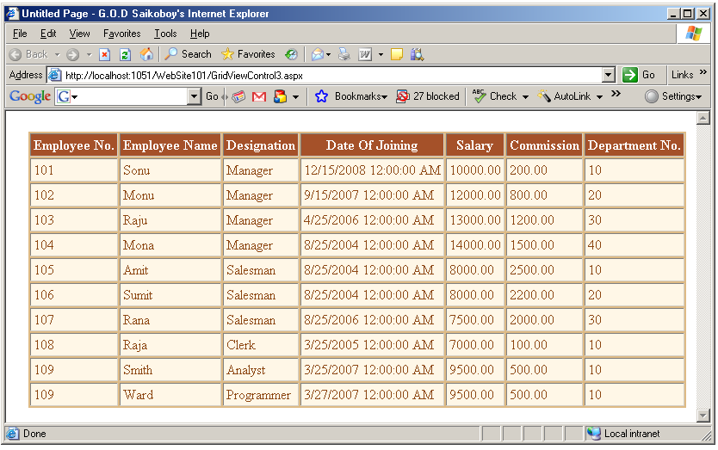

<asp:GridView ID="GridView1" runat="server" AutoGenerateColumns="False" Style="z-index: 100;
left: 26px; position: absolute; top: 24px" BackColor="#DEBA84" BorderColor="#DEBA84" BorderStyle="None" BorderWidth="1px" CellPadding="3" CellSpacing="2">
<Columns >
<asp:BoundField DataField ="EmpNo" HeaderText ="Employee No." />
<asp:BoundField DataField ="Ename" HeaderText ="Employee Name" />
<asp:BoundField DataField ="Desg" HeaderText ="Designation" />
<asp:BoundField DataField ="Hiredate" HeaderText ="Date Of Joining" />
<asp:BoundField DataField ="Sal" HeaderText ="Salary" />
<asp:BoundField DataField ="comm" HeaderText ="Commission" />
<asp:BoundField DataField ="DeptNo" HeaderText ="Department No." />
</Columns>
<FooterStyle BackColor="#F7DFB5" ForeColor="#8C4510" />
<RowStyle BackColor="#FFF7E7" ForeColor="#8C4510" />
<SelectedRowStyle BackColor="#738A9C" Font-Bold="True" ForeColor="White" />
<PagerStyle ForeColor="#8C4510" HorizontalAlign="Center" />
<HeaderStyle BackColor="#A55129" Font-Bold="True" ForeColor="White" />
</asp:GridView>
using System;
using System.Data;
using System.Configuration;
using System.Collections;
using System.Web;
using System.Web.Security;
using System.Web.UI;
using System.Web.UI.WebControls;
using System.Web.UI.WebControls.WebParts;
using System.Web.UI.HtmlControls;
using System.Data.SqlClient;

public partial class GridViewControl3 : System.Web.UI.Page
{
SqlConnection con;
SqlDataAdapter da;
DataSet ds;

protected void Page_Load(object sender, EventArgs e)
{
con = new SqlConnection("Integrated Security=SSPI;Persist Security Info=False;Initial Catalog=C#Prac;Data Source=.");
ds = new DataSet();
da = new SqlDataAdapter("SELECT * FROM Emp", con);
da.Fill(ds);
GridView1.DataSource = ds.Tables[0];
GridView1.DataBind();
}
}

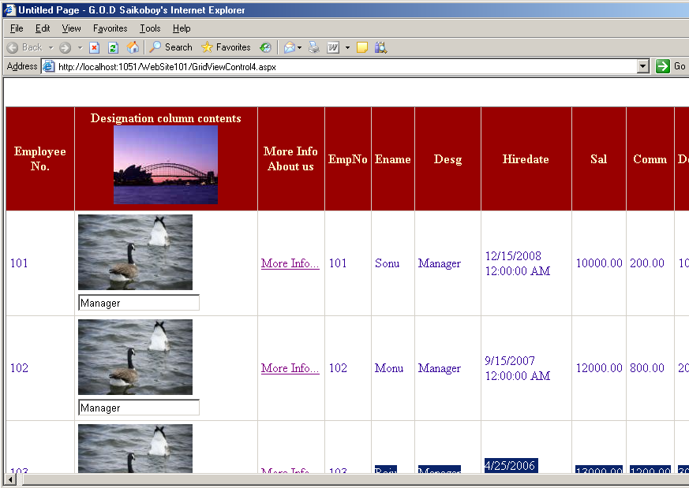

<%@ Page Language="C#" AutoEventWireup="true" CodeFile="GridViewControl4.aspx.cs" Inherits="GridViewControl4" %>

<!DOCTYPE html PUBLIC "-//W3C//DTD XHTML 1.0 Transitional//EN" "http://www.w3.org/TR/xhtml1/DTD/xhtml1-transitional.dtd">

<html xmlns="http://www.w3.org/1999/xhtml" >
<head runat="server">
<title>Untitled Page</title>
</head>
<body>
<form id="form1" runat="server">
<div>
<asp:GridView ID="GridView1" runat="server" BackColor="White" BorderColor="#CC9966"
BorderStyle="None" BorderWidth="1px" CellPadding="4" Style="z-index: 100; left: 9px;
position: absolute; top: 36px" Width="910px" Height="255px">
<Columns >
<asp:BoundField DataField ="EmpNo" HeaderText ="Employee No." />
<asp:TemplateField >
<HeaderTemplate >Designation column contents
<img src ="Images/1.jpg" alt ="No Image" />
</HeaderTemplate>

<ItemTemplate >
<img src ="Images/2.jpg" alt="No Image"/>
<asp:TextBox ID="tb1" Text ='<%#Eval("Desg") %>' runat ="server" ></asp:TextBox>
</ItemTemplate>

<FooterTemplate >
End of Designation column
</FooterTemplate>

</asp:TemplateField>

<asp:TemplateField >
<HeaderTemplate > More Info About us</HeaderTemplate>
<ItemTemplate >
<asp:HyperLink ID ="hlk1" NavigateUrl ="default2.aspx" runat ="server">More Info...</asp:HyperLink>
</ItemTemplate>
<FooterTemplate > End of Info.</FooterTemplate>
</asp:TemplateField>

</Columns>

<FooterStyle BackColor="#FaFFCC" ForeColor="#330099" />
<RowStyle BackColor="White" ForeColor="#330099" />
<SelectedRowStyle BackColor="#FFCC66" Font-Bold="True" ForeColor="#663399" />
<PagerStyle BackColor="#FFFFCC" ForeColor="#330099" HorizontalAlign="Center" />
<HeaderStyle BackColor="#990000" Font-Bold="True" ForeColor="#FFFFCC" />
</asp:GridView>

</div>
</form>
</body>
</html>

using System;
using System.Data;
using System.Configuration;
using System.Collections;
using System.Web;
using System.Web.Security;
using System.Web.UI;
using System.Web.UI.WebControls;
using System.Web.UI.WebControls.WebParts;
using System.Web.UI.HtmlControls;
using System.Data.SqlClient;

public partial class GridViewControl4 : System.Web.UI.Page
{
protected void Page_Load(object sender, EventArgs e)
{
SqlConnection con;
SqlDataAdapter da;
DataSet ds;

con = new SqlConnection("Integrated Security=SSPI;Persist Security Info=False;Initial Catalog=C#Prac;Data Source=.");
ds = new DataSet();
da = new SqlDataAdapter("SELECT * FROM Emp", con);
da.Fill(ds);
GridView1.DataSource = ds.Tables[0];
GridView1.DataBind();
}
}
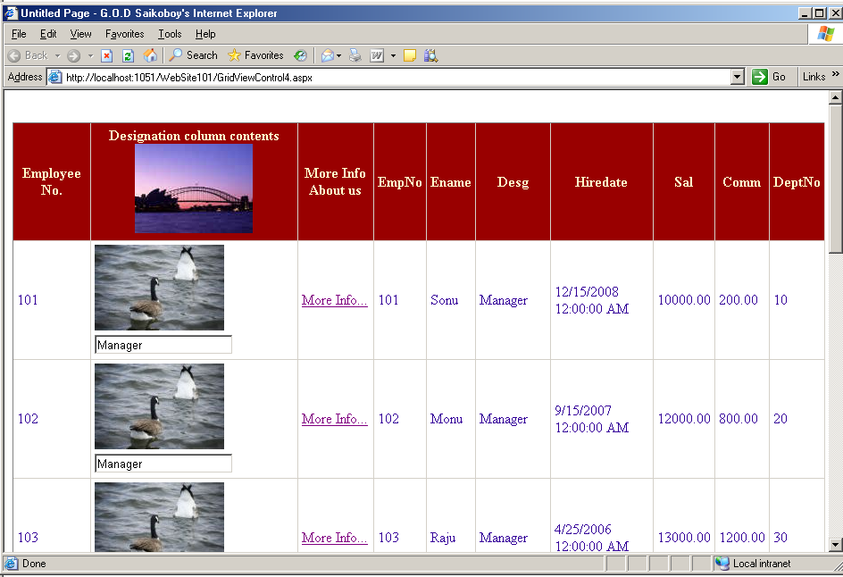
Q. Repeater example :
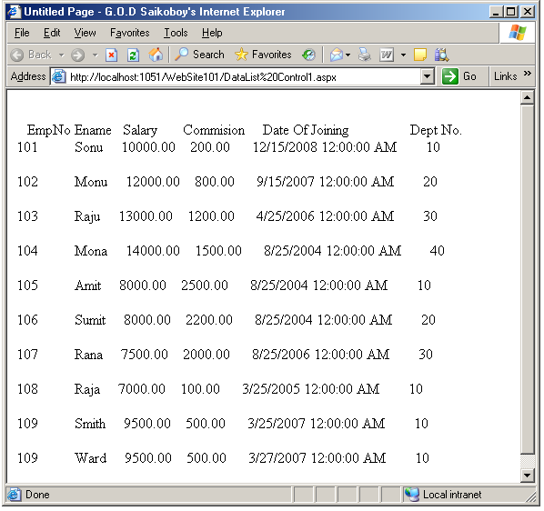

<asp:Repeater ID ="Repeater1" runat ="server" >
<HeaderTemplate >
EmpNo EnameSalary Commision Date Of Joining Dept No.
</HeaderTemplate>
<ItemTemplate >

<br />
<%#Eval ("EmpNo") %>
<%#Eval ("Ename") %>
<%#Eval ("Sal") %>
<%#Eval ("Comm") %>
<%#Eval ("Hiredate") %>
<%#Eval ("DeptNo") %>
<br />
</ItemTemplate>

</asp:Repeater>

using System;
using System.Data;
using System.Configuration;
using System.Collections;
using System.Web;
using System.Web.Security;
using System.Web.UI;
using System.Web.UI.WebControls;
using System.Web.UI.WebControls.WebParts;
using System.Web.UI.HtmlControls;
using System.Data.SqlClient;

public partial class DataList_Control1 : System.Web.UI.Page
{
SqlConnection con;
SqlDataAdapter da;
DataSet ds;

protected void Page_Load(object sender, EventArgs e)
{
con = new SqlConnection("Integrated Security=SSPI;Persist Security Info=False;Initial Catalog=C#Prac;Data Source=.");
ds = new DataSet();
da = new SqlDataAdapter("SELECT * FROM Emp", con);
da.Fill(ds);
Repeater1.DataSource = ds.Tables[0];
Repeater1.DataBind();
}
}

